**Experiment 2: To perform Time Division Multiplexing (TDM) of analog signals.**

**Theory:**

Time division multiplexing is a technique of transmitting more than one information on the same channel. As can be noticed from the figure below the samples consists of short pulses followed by another pulse after a long time interval. This no-activity time intervals can be used to include samples from the other channels as well. This means that several information signals can be transmitted over a single channel by sending samples from different information sources at different moments in time. This technique is known as time division multiplexing or TDM. TDM is widely used in digital communication systems to increase the efficiency of the transmitting medium. TDM can be achieved by electronically switching the samples such that they inter leave sequentially at a correct instant in time without mutual interference.



**Figure 1 : Pulse Amplitude Modulated wave with large time Intervals between samples**

**Circuit:**

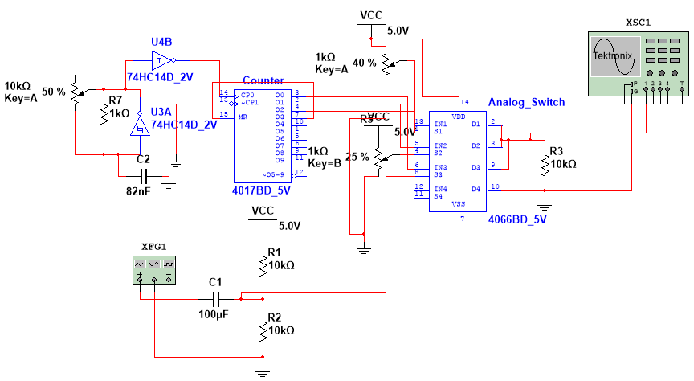

**Procedure:**

**Step-1**

1. Connect the circuit as per the figure above.
2. Set the function generator frequency to 1KHz.
3. Observe the output at pin 3 of Analog Switch IC.
4. Change the slider at Key A and Key B and observe the effect on multiplexed wave.

**Step-2**

1. Change the frequency equal to last two digits of your enrollment no. from Function generator and observe the effect on multiplexed wave.
2. Change the key A and B, observe the effect on duty cycle.

**Output Wave form:**

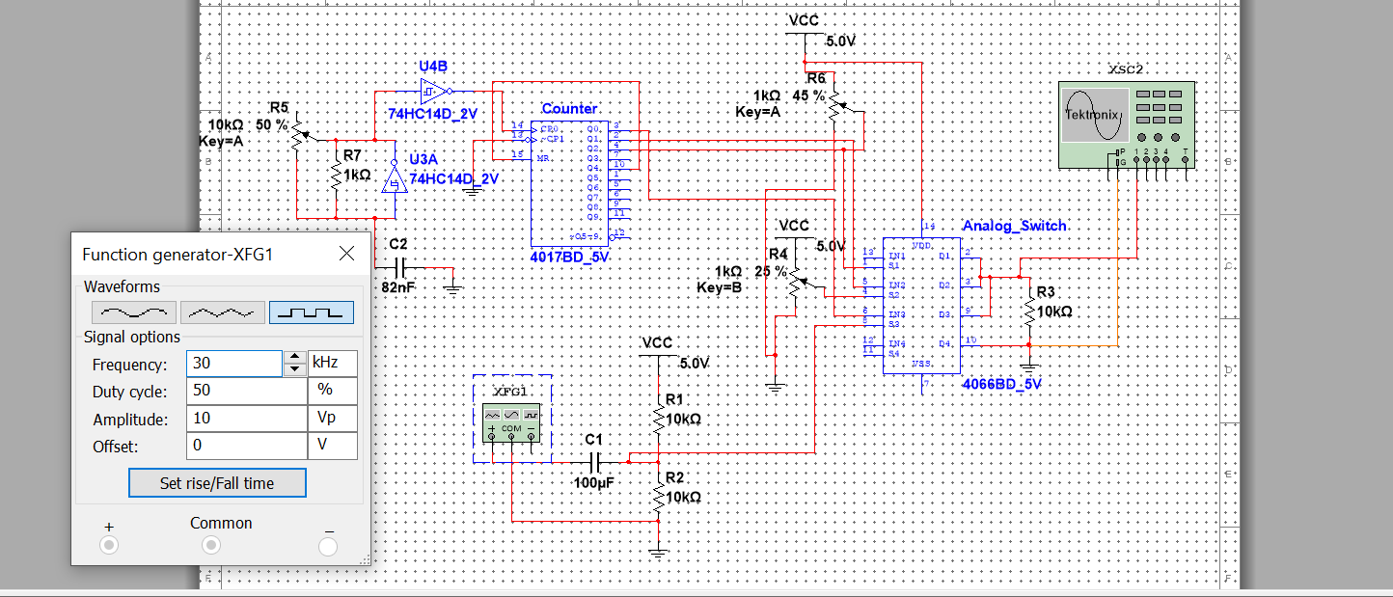

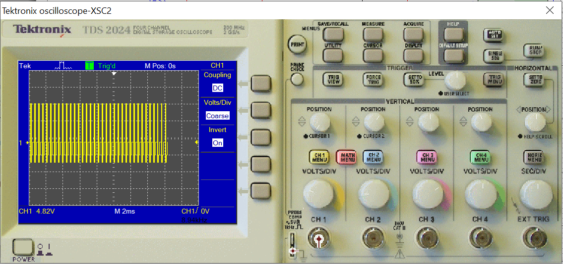

**Observation:**

**Conclusion:**

**Post Lab Exercise**

|  |  |
| --- | --- |
| **Q-1**. | **Apply two AC input signal to the from function generator and draw the multiplexed waveform.** |
|  |  |
| **Q-2** | **Apply two DC input signal to the from function generator and draw the multiplexed waveform.** |
|  |  |
| **Q-3** | **Apply one DC and one AC input signal to the from function generator and draw the multiplexed waveform.** |
|  |  |